<Re:Book>

Software Architecture Document

Version <1.0>

Revision History

| **Date** | **Version** | **Description** | **Author** |
| --- | --- | --- | --- |
| <27/11/2021> | <1.0> |  | <Dinh Dinh, Khoi Quach, Ngan Nguyen, Thu Nguyen, My Le> |
|  |  |  |  |
|  |  |  |  |
|  |  |  |  |

Table of Contents

**Introduction** **4**

1.1 Purpose 4

1.2 Scope 4

1.3 Definitions, Acronyms and Abbreviations 4

1.4 References 4

**Architectural Goals and Constraints** **4**

Security 4

**Use-Case Model** **4**

**Logical View** **5**

Package: Front-end: 7

**Deployment** **8**

**Implementation View** **8**

Software Architecture Document

# Introduction

## 1.1 Purpose

This paper depicts several features of the system using a variety of architectural viewpoints. Its purpose is to document and communicate the system's most important design decisions.

## 1.2 Scope

This Software Architecture Document provides an architectural overview of the website Re:Book. The Re:Book is being developed by Group 5 to support reviewing and publishing books.

## 1.3 Definitions, Acronyms and Abbreviations

## 1.4 References

# Architectural Goals and Constraints

There are some key requirements and system constraints that have a significant bearing on the architecture. They are:

## Security

The system must be secure, because we handle user related information.

Authentication: Login with username and password

Password security: Passwords will be hashed and salted.

SSL: To prevent man-in-the-middle attacks.

# Use-Case Model

<https://drive.google.com/file/d/10CaMWRM_T98fZHymYlrWNjY1z3_D5xou/view?usp=sharing>

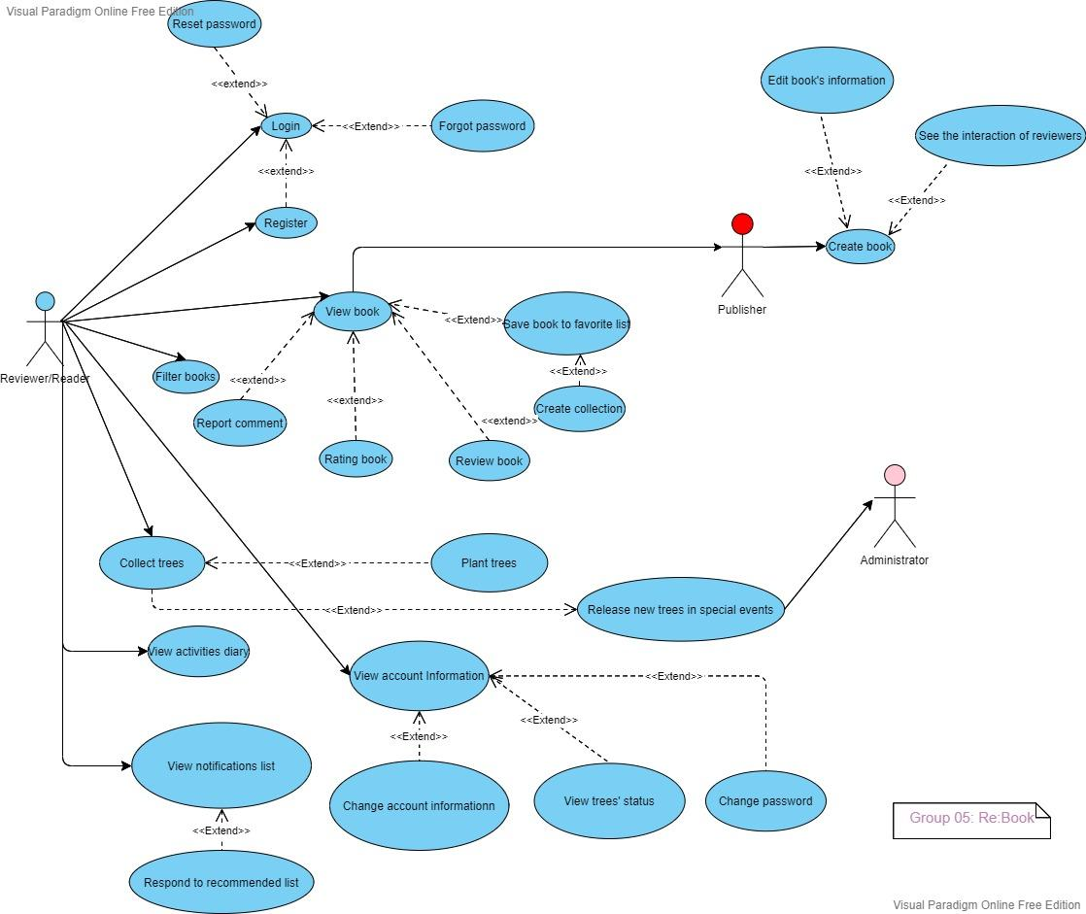

# Logical View

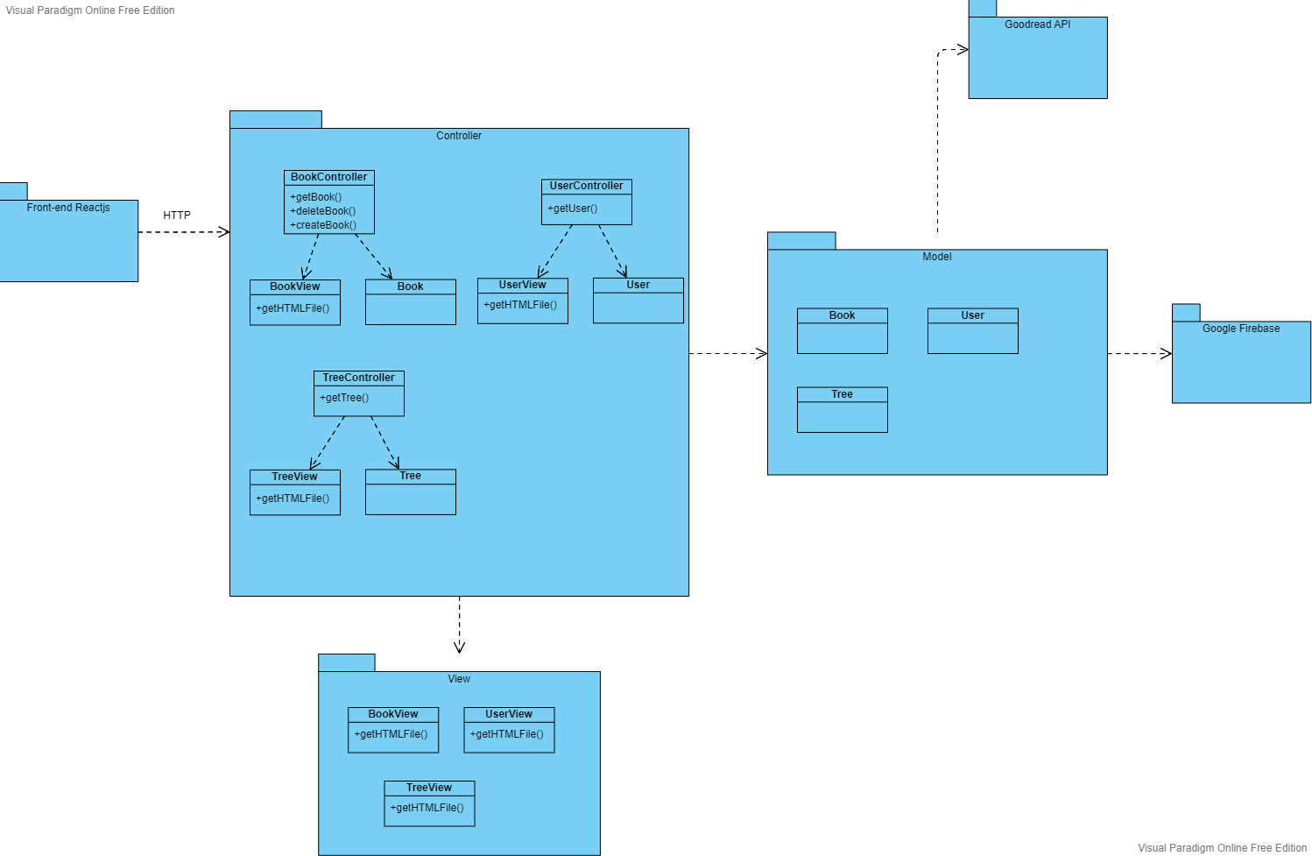

For detail: [Package Diagram.png](https://drive.google.com/file/d/1atGGthNGWnGHRhvCMXc8ohAb_dXgq7Rj/view?usp=sharing)

## Package: Front-end:

* Description: UI component for users to interact with.
* Language: Javascript
* Framework: React.js
  1. **Package: Controller:**

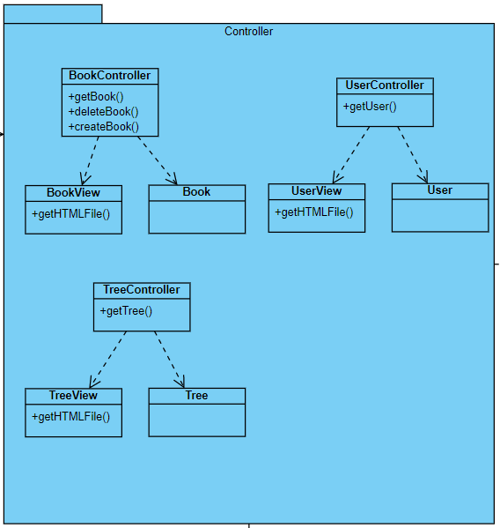

* Description: Controller is a component to control the internal backend workflow.
* Language: JavaScript
  1. **Package: View:**

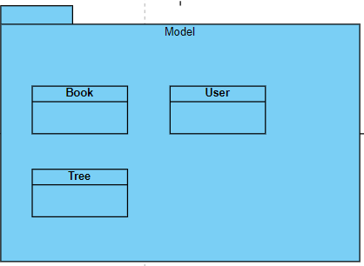

* Description: View is a component to represent the data retrieved from the database as an HTML file.
* Language: Javascript
  1. **Package: Model:**

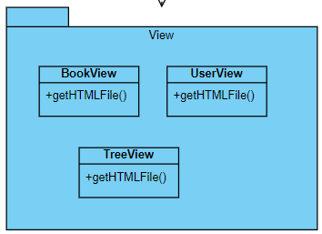

* Description: Model is a component containing objects for storing the data from the database
* Language: Javascript
  1. **Package: Goodread API:**
* Description: The Goodreads API allows developers access to Goodreads data in order to help websites or applications that deal with books be more personalized, social, and engaging.
  1. **Package: Google Firebase:**
* Description: Google's Firebase technology supports web applications, allowing secure access to the database directly from client-side code
* Data is saved in JSON format and synced in real time across all connected clients.

# Deployment

# Implementation View